HOW TO: Finding an in-network Cigna provider in your location:
Click on this link: https://hcpdirectory.cigna.com/web/public/consumer/directory
Choose ‘Employer or School’
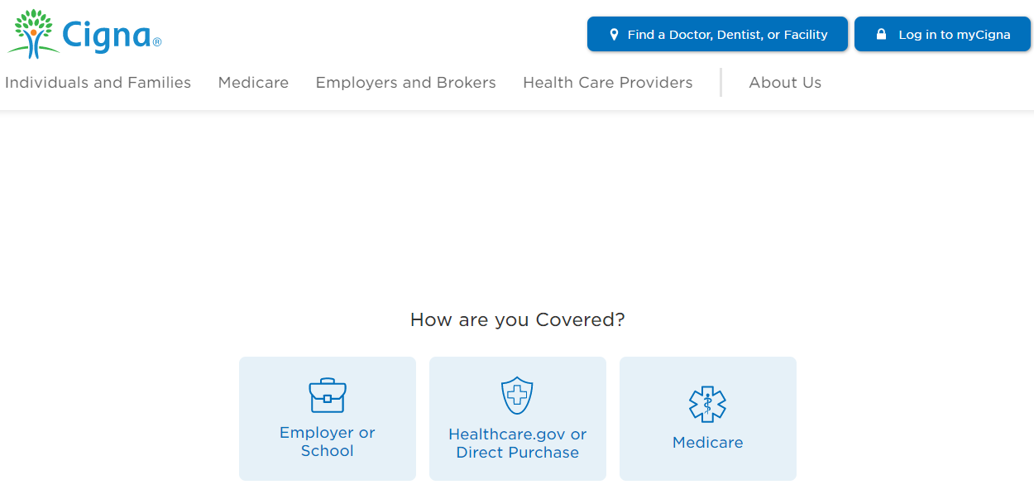
Enter your address, city or zip code here:
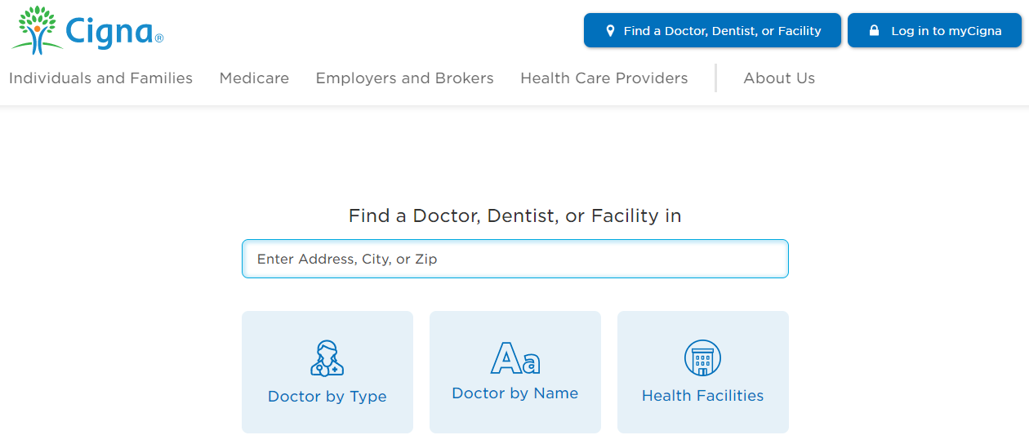

Choose the provider type you are seeking:
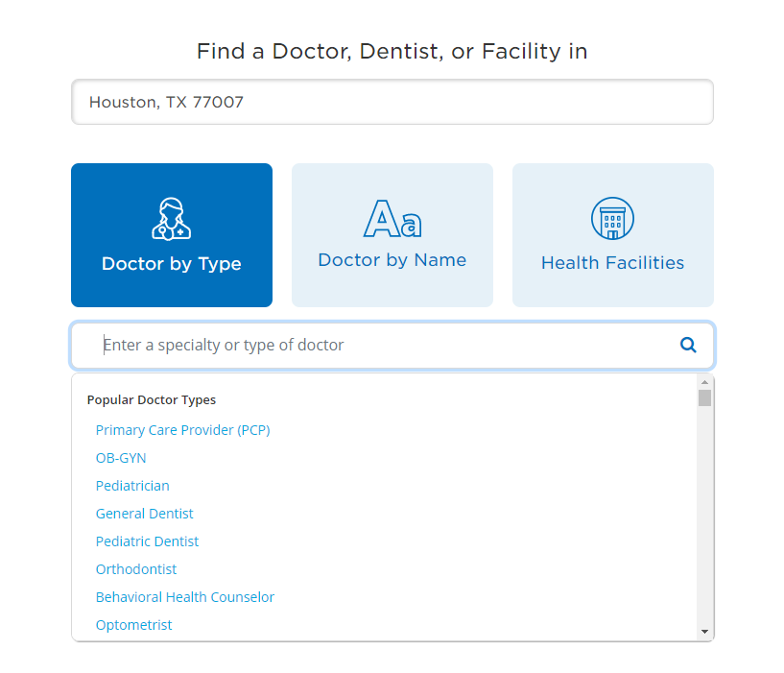
Choose ‘Continue as Guest’ (bottom right)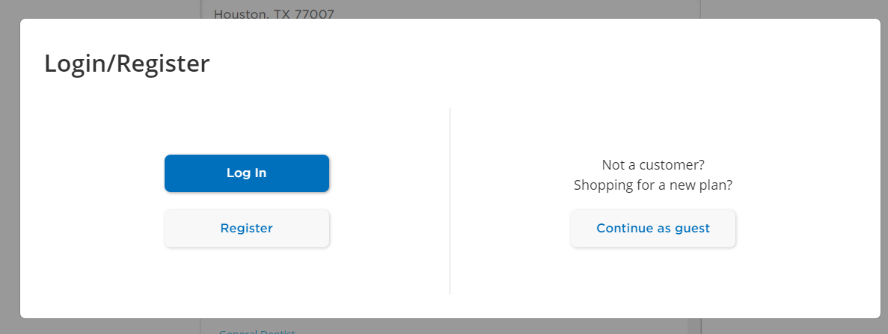

Click Continue again,
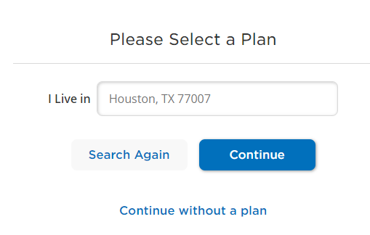
Choose ‘Open Access Plus’ below
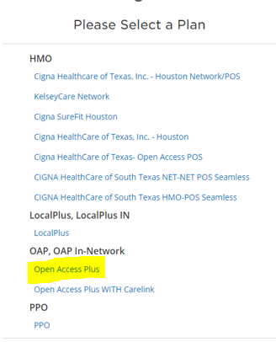
You will then be presented with a list of in-network providers near the address, city or zip code that you entered.

